Upload to project to the web directory

**Open config.php and update as per your requirements db and creds**

**Then open phpMyAdmin**

**Create a database after creating click on sql**

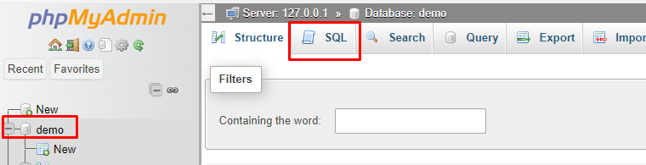

**Paste the mention below code to the sql tab  
------------------------------------------------------------------------------------------------------------------------------------------**

CREATE TABLE users ( id INT NOT NULL PRIMARY KEY AUTO_INCREMENT, username VARCHAR(50) NOT NULL UNIQUE, password VARCHAR(255) NOT NULL, created_at DATETIME DEFAULT CURRENT_TIMESTAMP );

**Table users created.**

**Project is ready**

